C language notes

Inhoud

Basic structure 5

Sending text to output with puts 5

Comments 6

Printf() 6

Escape sequences 7

Placeholders and values 7

Variables 8

Using Input and Output 8

Scanf() 9

Strings 9

Doing Math 10

If statements 10

Single if statement 10

Else 11

Else if 12

Switch 13

While 14

For 15

Nested loops 16

Functions 17

Normal functions 17

Passing values to functions 18

Returning a value 19

Manipulating characters 20

Manipulating strings 21

Constants 21

Arrays 22

Normal arrays 22

Multidimensional arrays 23

Structures 24

Exploring variables 24

Pointers 25

Pointers 25

Using pointers 26

Accessing pointers with arrays 26

Pointer functions 27

Normal functions 27

Pointers in functions 28

Working with pointer arrays 29

Allocating memory 30

# Basic structure

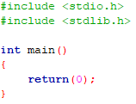

# Sending text to output with puts

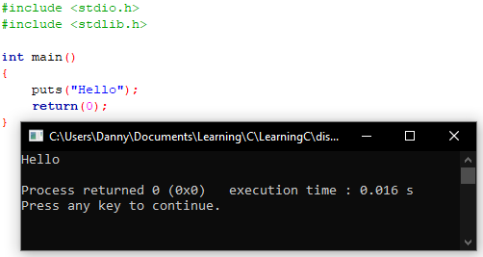

# Comments

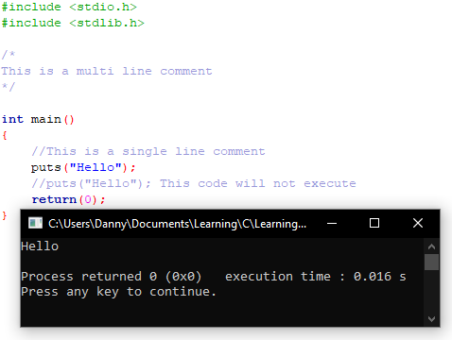

# Printf()

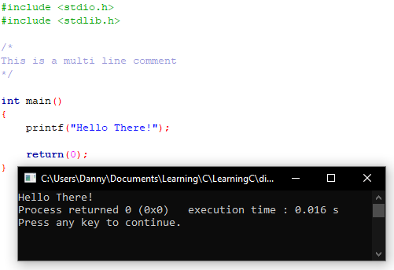

# Escape sequences

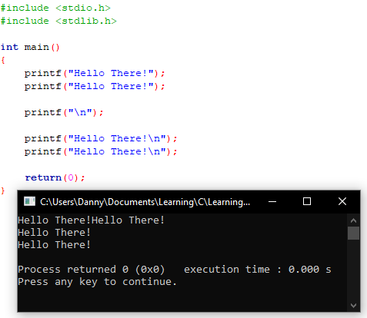

# Placeholders and values

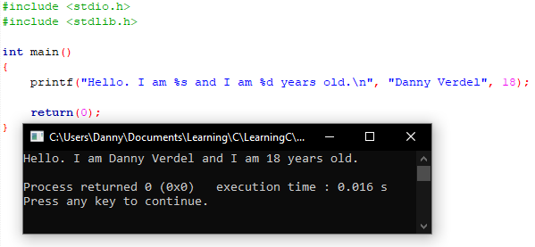

# Variables

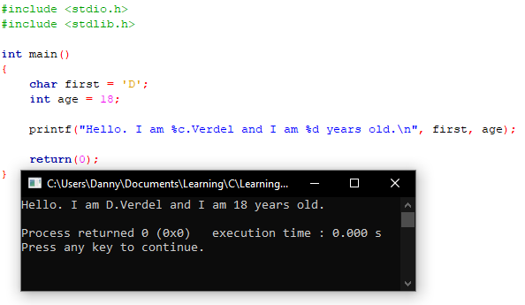

# Using Input and Output

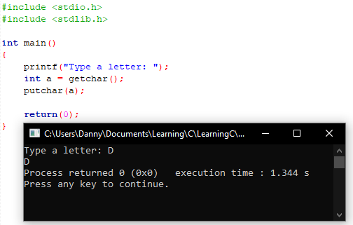

# Scanf()

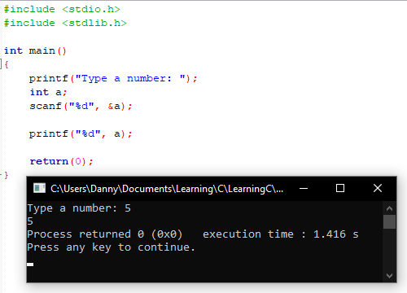

# Strings

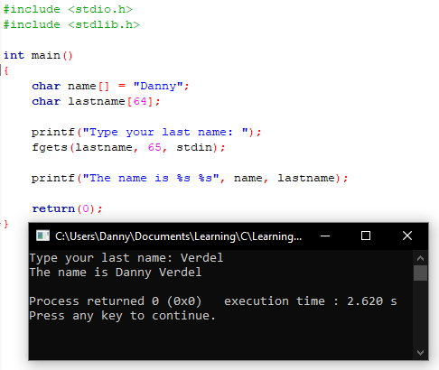

# Doing Math

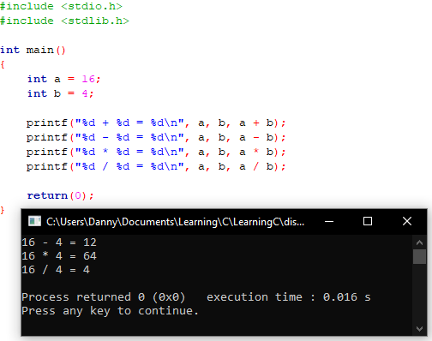

# If statements

## Single if statement

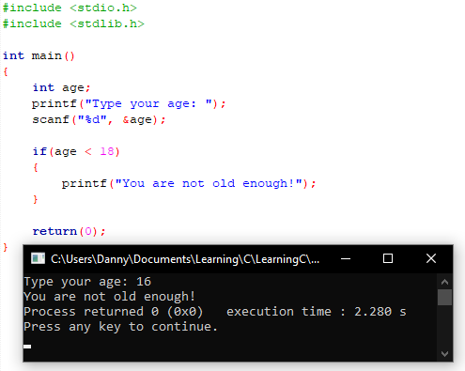

## Else

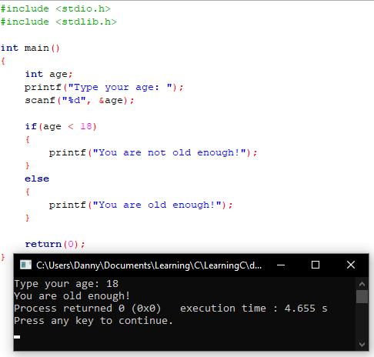

## Else if

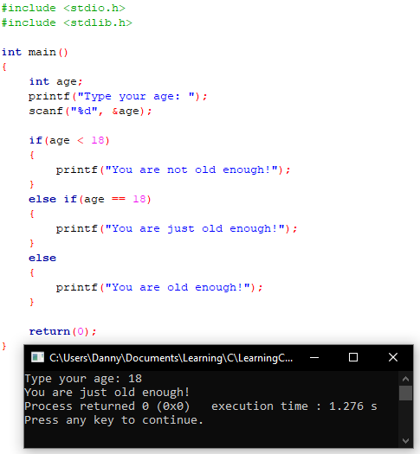

# Switch

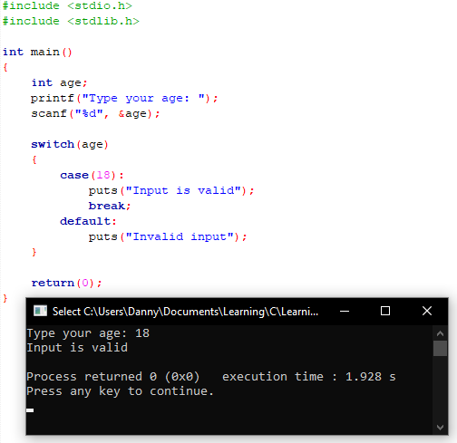

# While

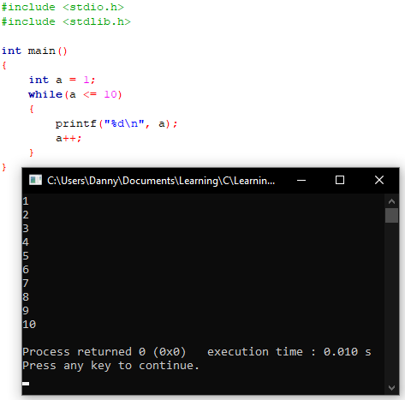

# For

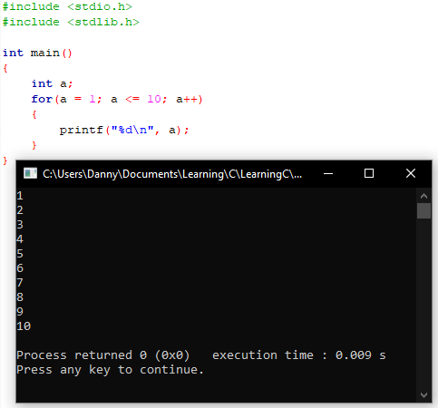

# Nested loops

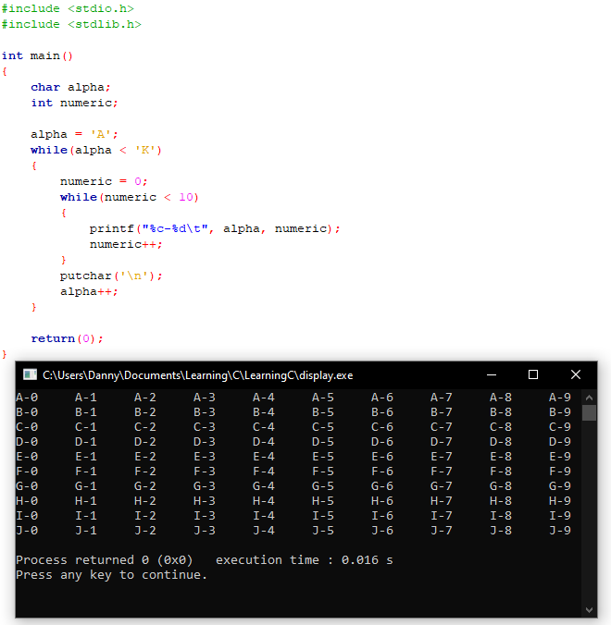

# Functions

## Normal functions

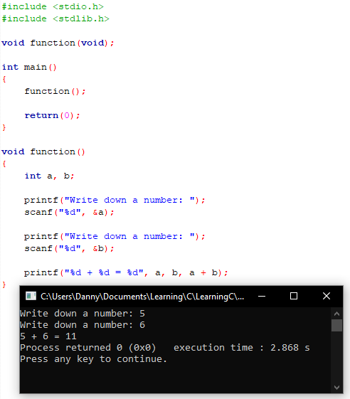

## Passing values to functions

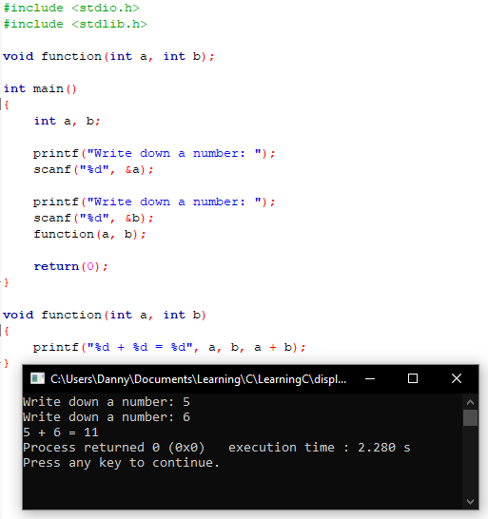

## Returning a value

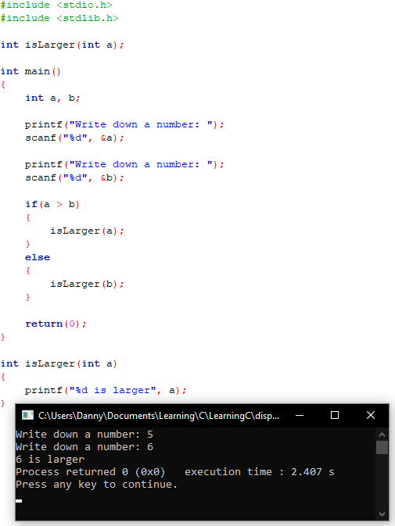

# Manipulating characters

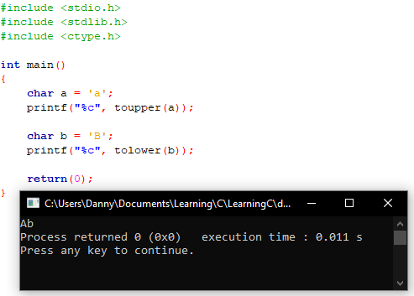

# Manipulating strings

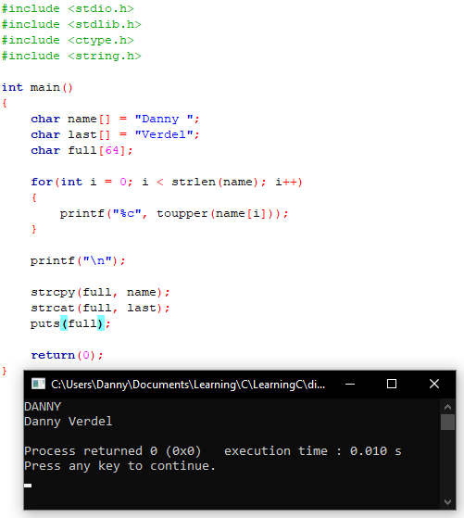

# Constants

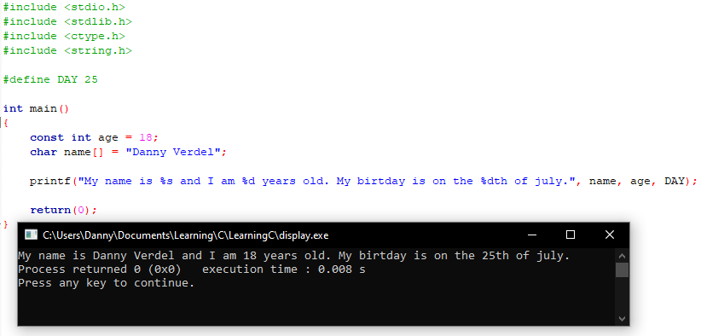

# Arrays

## Normal arrays

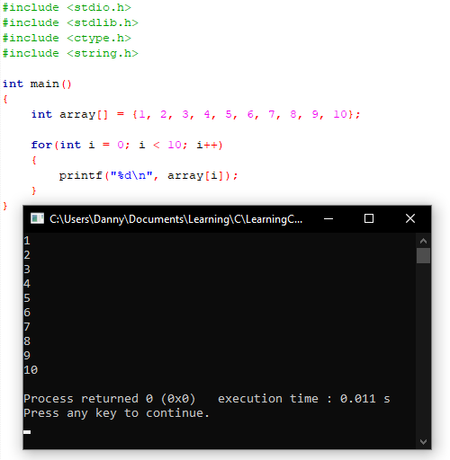

## Multidimensional arrays

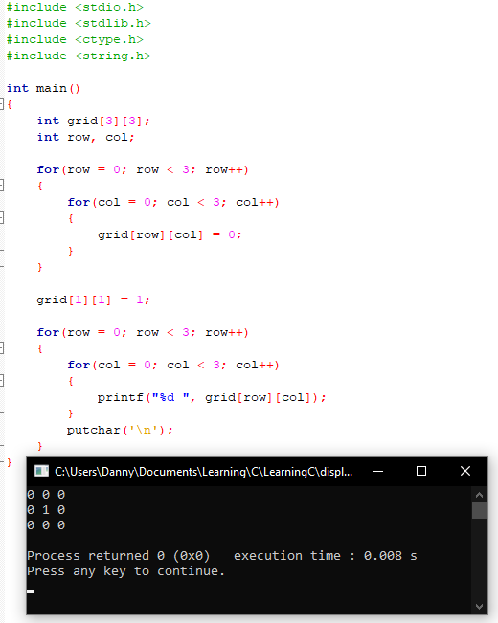

# Structures

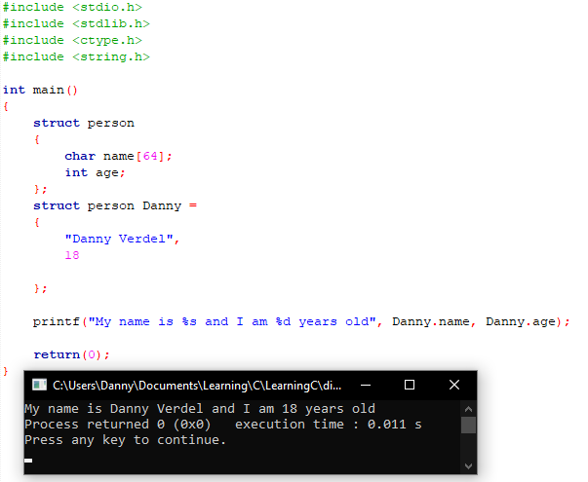

# Exploring variables

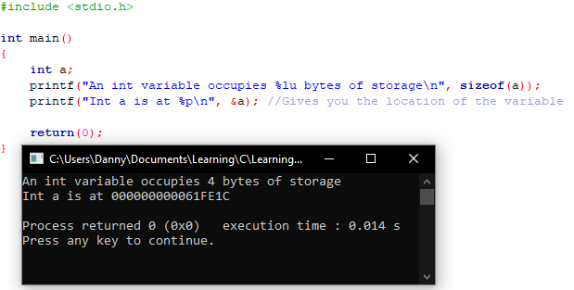

# Pointers

## Pointers

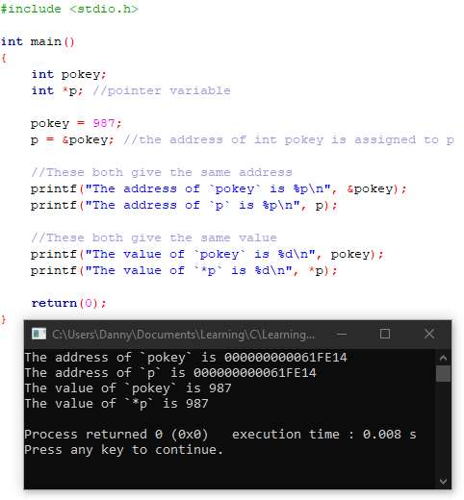

## Using pointers

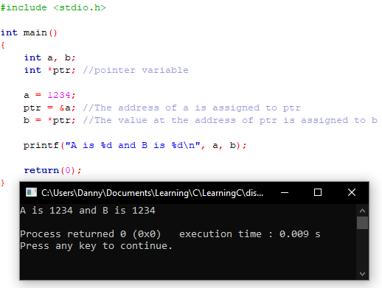

# Accessing pointers with arrays

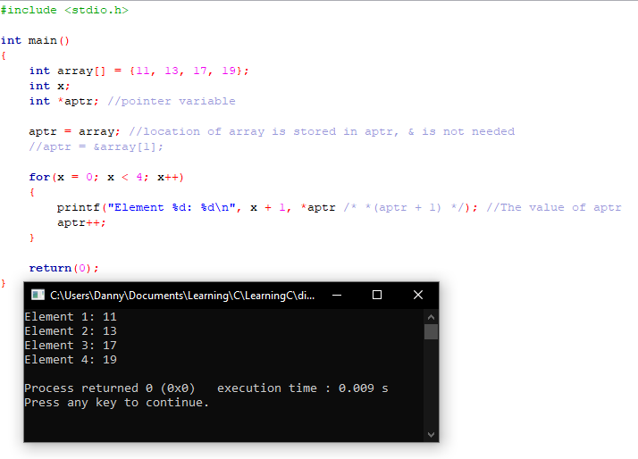

# Pointer functions

## Normal functions

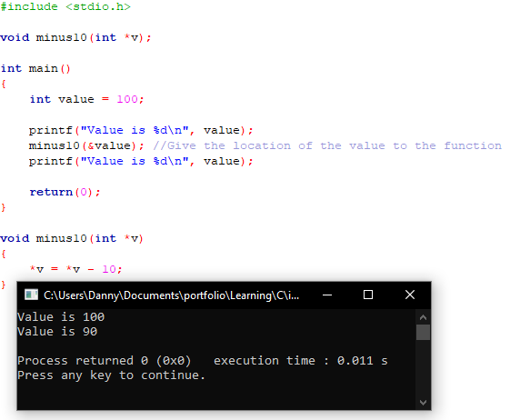

## Pointers in functions

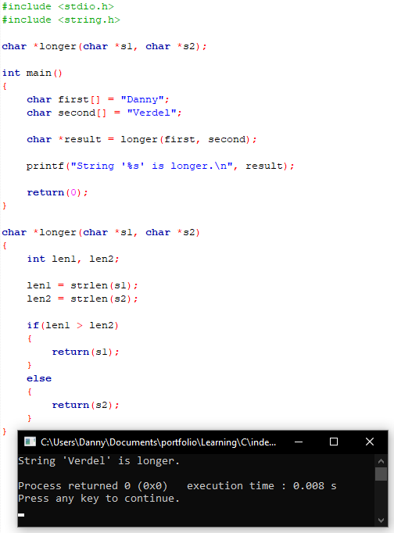

# Working with pointer arrays

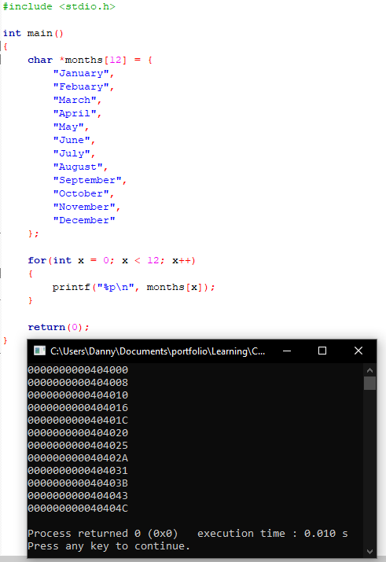

# Allocating memory

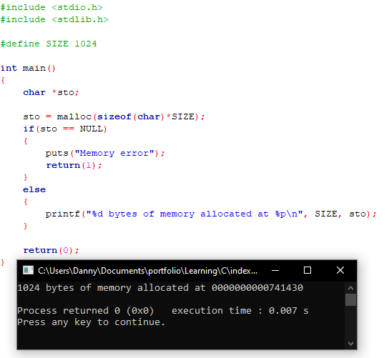

# Ternary operator

